

**Satellite Geodesy**

**“Phase Double Differences Solution”**

Lab-3

|  |  |
| --- | --- |
| Instructor | [Wolfgang Keller](mailto:keller@gis.uni-stuttgart.de%20(Wolfgang%20Keller)) |

**Contents**

|  |  |  |  |
| --- | --- | --- | --- |
| 1. | Aim | | 3 |
| 2. | Introduction | | 3 |
| 3. | Objective | | 3 |
| 4. | Explanation: | |  |
|  | 1. | Computing the double difference solution | 4 |
|  | 2. | Approximate the matrix 𝑸𝟐𝟐 by its main diagonal | 8 |
|  | 3. | Compute the confidence Sphere for the ambiguity | 9 |
|  | 4. | Resolve the ambiguity double differences. | 9 |
| 6. | Conclusion | | 10 |

7. Reference 10

**Aim**

To compute and analysis positions of the two receivers in differential GPS using phase double difference solution.

**Introduction**

When the same satellite has been observed simultaneously from two different receivers with a baseline distance of 15 km, then the ionospheric and the tropospheric delays at both receivers are almost the same and cancel out. This is the principle of differential GPS. There are mainly three ways to do this job.

* Code Differences
* Phase Single Differences
* Phase Double Differences

Since the phase noise is 1000 times smaller than the code noise the phase solution would be much accurate than code differences solution. However, in single phase difference setup the clock parameters and the ambiguity parameters cannot be separated, which can only possible by double differences. A double difference is the difference of two single differences between two different satellites.

**Objective**

The main objectives of this lab are:

* To compute the double differences solution
* To approximate the matrix Q22 by its main diagonal
* To compute the confidence sphere for the ambiguity double differences.
* To Resolve the ambiguity double differences

**Explanation:**

1. **Compute the double differences solution**

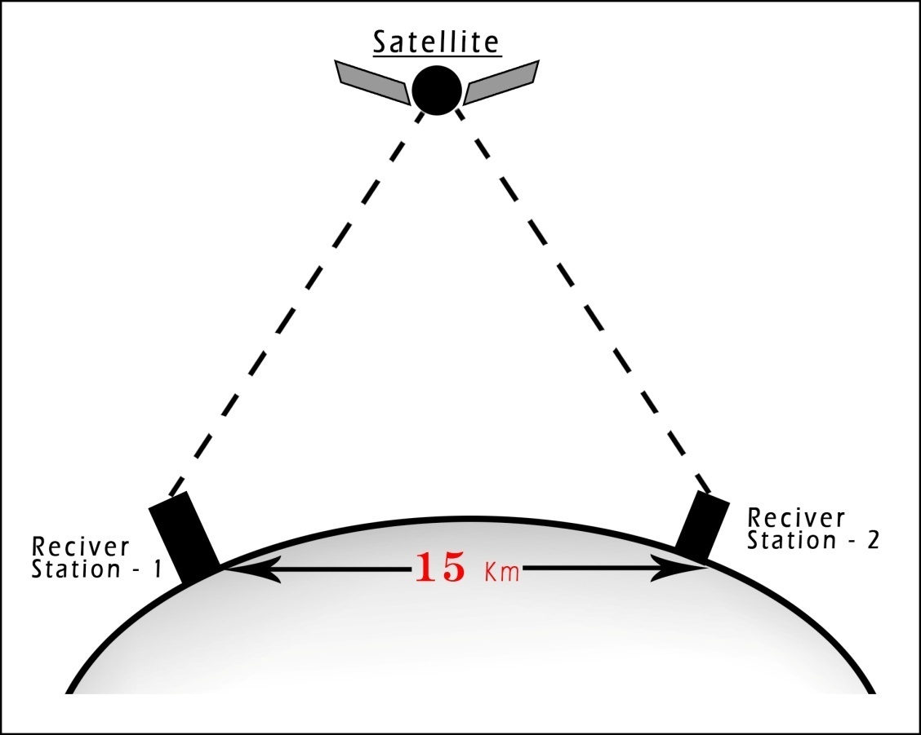

Fig. 1

The phase observation model is given by (Here the number of satellites k=11):



The upper index refers to the satellite, while the lower index refers to the receiver. From this *2 k* observations *k* single differences can be formed.



The k-1 double differences are the subtraction of the single differences from the 1,⋯,𝑘−1 satellites to the 𝑘 satellite:



We have one satellite as reference satellite which has to be fixed. This is to eliminate all the clock parameters and to make the double differences of the integer ambiguity parameters are again integer.

The linear zed function model is: 

This can be written as matrix product of the single differences:



In mat-lab this has been done by:

DEL_PHI_1=D*DELTA_PHASE(1:k);

for i=1:Epochs-1

del_phi_2=D*DELTA_PHASE( ((i*k)+1):((i*k)+k) );

DEL_PHI_1=[DEL_PHI_1;del_phi_2]; % Delta Phi - 1 for Y vector

end

An adjustment process is performed to find out the ambiguity vector. The adjustment model would be the Guss-Markov model:

|  |
| --- |
| 𝐘=𝐀 𝛃 +𝛆 |

|  |
| --- |
| 𝛃=*tran*(Δ𝐛𝑇,∇𝑁1,⋯,∇𝑁𝑘−1) |

The estimation vector is: This consists of the baseline correction and the ambiguity double differences

**Observation Vector:**

The observation vector **Y** for n=25 epoch has been calculated. The initial vector **∇Φ0** is computed by the double differences of the approximate distance (since the positions of satellites and the approximate positions of the receivers are known) between the satellites and the observer, with similar procedure of the computation of the phase double difference:

In mat-lab it has been done by following code:

**DELTA_PHASE=phase1(:,1)-phase2(:,1); % Phase Single differences**

**DEL_PHI_1=D*DELTA_PHASE(1:k);**

**for i=1:Epochs-1**

**del_phi_2=D*DELTA_PHASE( ((i*k)+1):((i*k)+k) );**

**DEL_PHI_1=[DEL_PHI_1;del_phi_2]; % Delta Phi - 1 for Y vector**

**end**

**phase_10=zeros(275,1);**

**for i=1:275**

**phase_10(i)=sqrt(Dir_Vec_1(i,1:3)*Dir_Vec_1(i,1:3)');**

**end**

**phase_20=zeros(length(Sat),1);**

**for i=1:length(Sat)**

**phase_20(i)=sqrt(Dir_Vec_2(i,1:3)*Dir_Vec_2(i,1:3)');**

**end**

**Delta_Phase_0=phase_10-phase_20; % Single Differences**

**DELTA_PHI_0=D*Delta_Phase_0(1:k);**

**for i=1:Epochs-1**

**Delta_Phi_2=D*Delta_Phase_0((i*k+1):(i*k+k));**

**DELTA_PHI_0=[DELTA_PHI_0;Delta_Phi_2]; % Delta Phi - 0 for Y vector**

**end**

**Y=[DEL_PHI_1-DELTA_PHI_0]; % Y - Observation Vector**

**Design Matrix:**

The design matrix is given by:

Where:

*  shows the normal vectors of relative vector between satellite 𝑘=11 and the receiver in epoch n=25.
* 𝜆 is the wavelength of 𝑓1 frequency.



* 𝑓1=1575.42 MHz
* with c =299792458 m/s
* The Weight matrix of single epoch is given by (inverse of covariance matrix):



Therefore, the multi-epoch weight matrix is thus derived by a block diagonal matrix having the single epoch weight matrix (**P**) in its diagonal:

In Mat-lab:

P=(-ones(10,10)+ diag(k*ones(k-1,1)))*(1/k);

P_bar=P;

for i=1:Epochs-1

P_bar=blkdiag(P_bar,P); % Multi epoch Weight Matrix (Block diag matrix)

end

**Least Square Estimates**

The least square estimate is given by:

|  |
| --- |
|  |

The result from matlab:

1. The change in unknown coordinate corrections:



= *Beta_Hat_1 =* ***[***  *-2.8826, -81.5066, -18.0775****]*** *in Meters*

2. The ambiguities:

=*Beta_Hat_2 =* ***[*** *-17.9909, -76.0157, -60.9937, -294.0005, -244.0008,*



*-197.0038, -46.0045, 57.0052, -266.0077, 37.0044* ***]***

1. **Approximate the matrix 𝑸𝟐𝟐 by its main diagonal.**

Split the estimation parameters into two parts. One part is the baseline correction estimation and another part is the estimated ambiguity vector.



Accordingly, the design matrix is separated into two parts.



Hence the normal equation contains four parts:

The inverse of the norm equation is also divided into four blocks:



In Mat-lab:

Beta_Hat_1=Beta_Hat(1:3) % Estimates for position differences (Delta-b)

Beta_Hat_2=Beta_Hat(4:3+(k-1)) % Float estimates of the Int. Ambiguities

A1=A(:,1:3);

A2=A(:,4:3+(k-1));

N=[A1'*P_bar*A1,A1'*P_bar*A2;A2'*P_bar*A1,A2'*P_bar*A2]; % Normal Equation Matrix

Q=inv(N); % Inverse of normal Euation Matrix

Q22_ori=Q(4:(3+(k-1)),4:(3+(k-1)));

Q22=diag(Q22_ori)

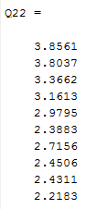The diagonal elements of the matrix finally:

1. **Computation of confidence Sphere for Ambiguity Double Differences**

The precision of the previous estimation process is given by:

with m=250,u=13

The longest major axis is:

Which indicates that there is only one candidate of the ambiguity fixing.

Round the float the estimated ambiguity vector and plug in into the probability test:



In Mat-lab:

Sigma_Square=(Y-A*Beta_Hat)'*P_bar*(Y-A*Beta_Hat)/(250-13)

Sigma=sqrt(Sigma_Square)

Long_Axis=sqrt(Sigma_Square*W_Max*284.66)

Beta_2=round(Beta_Hat_2)

**4) Resolve the ambiguity double differences.**

The ambiguity double difference is:

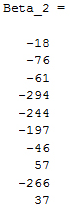

The resolved difference in position changes of the recivers:

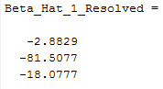

**Conclusion**

The double phase differences gives the most effective results by which we can bring down the baseline errors in the centimetre range.

Here the results are:

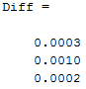 in Meter

**Reference**

1. Notes
2. Wikipedia

**\*\*\*\*\***